Customize an Arc Shape

Define an Arc Shape as below:
Note: A200 is dimension of arc length. R80 is dimension of arc radius. Unit is Metric.

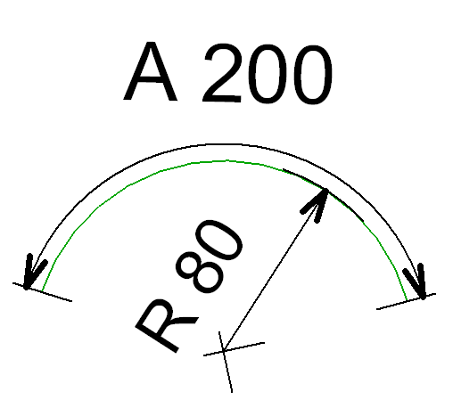

Step by step to define above Arc shape:
1) Input “MyArc_1” in Name, and select Arc. Picture as below:
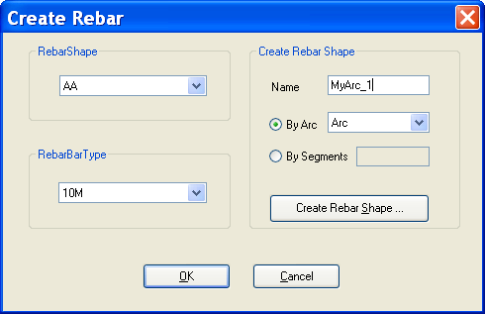

2) After the first step, “Create RebarShape” will be present as below:
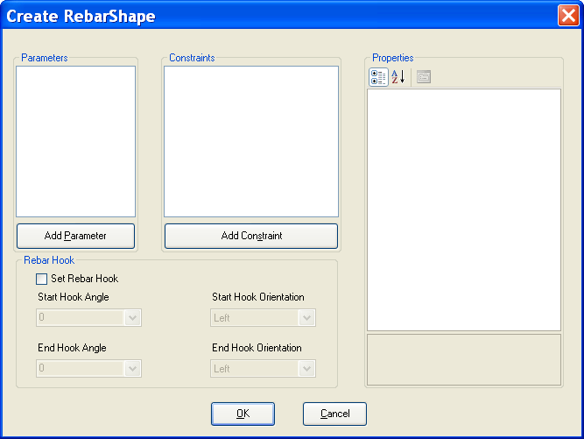

3) Add a double parameter R = 80.
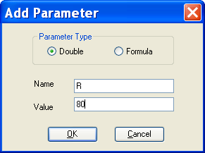

4) Add a double parameter A = 200.
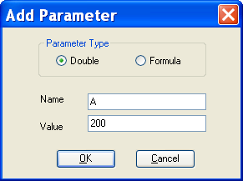

5) After adding two parameters R and A, the result look like below:
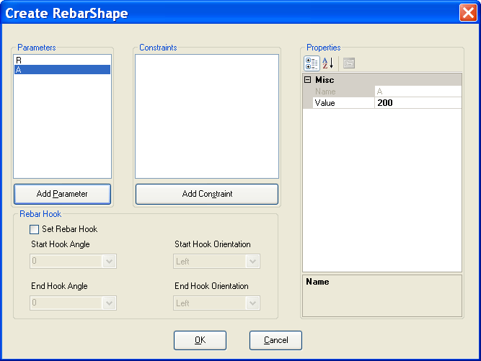
6) Add ConstraintRadius and set its values as below:
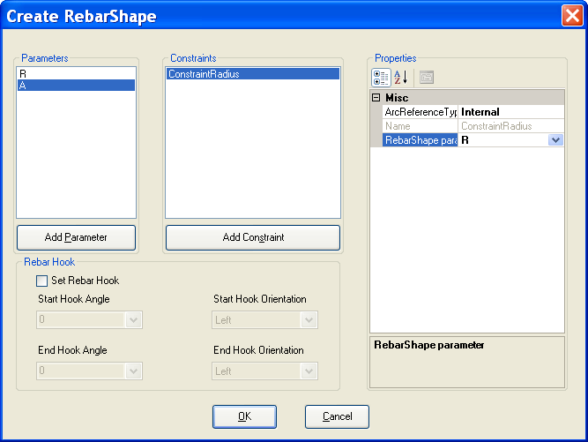

7) Add ConstraintArcLength and set its values as below:
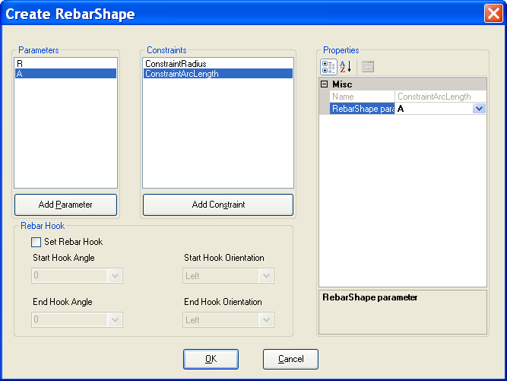

8) Check “Set Rebar Hook” and set hook angles and hook orientations.
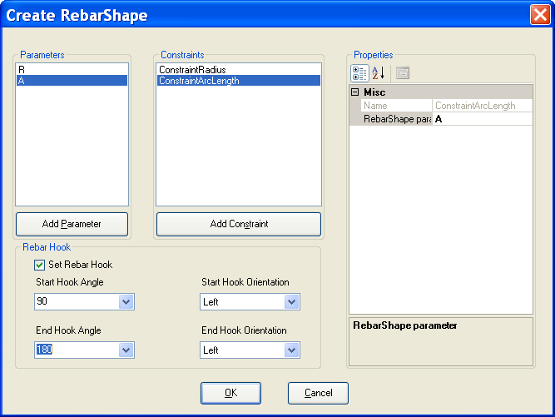

9) After all above steps, “MyArc_1” is added to Revit document.
